Copy and Paste Study Design

Journal of GME (<http://www.jgme.org/page/hottopics/electronic-health-record?code=gmed-site)>

http://www.jgme.org/page/author_instructions?code=gmed-site

Educational Innovation

**Educational Innovation:** A description of a new approach or strategy in medical education that has been implemented and assessed, limited to 2,000 words.

Educational Innovation manuscripts should answer the question: Should this innovation be tried (or avoided) in other settings or disciplines?

* Submissions should use the structured abstract and paper format, and must include a statement on IRB review (see Original Research manuscripts above).
* Structured abstract must include the total possible number of participants, the actual number of participants, and the percentage must be calculated and included in the Results section of the abstract (as well as the main text) Authors with questions should contact JGME [editorial staff](mailto:jgme@acgme.org).
* Studies should focus on novel educational strategies, and have potential for replication in other disciplines/settings.
* Descriptions must be sufficiently detailed to allow others to replicate the approach, and must include feasibility information (time, costs/materials, and acceptability) as relevant.
* Of note, innovations do not have to be successful; manuscripts may report on approaches others should NOT try.

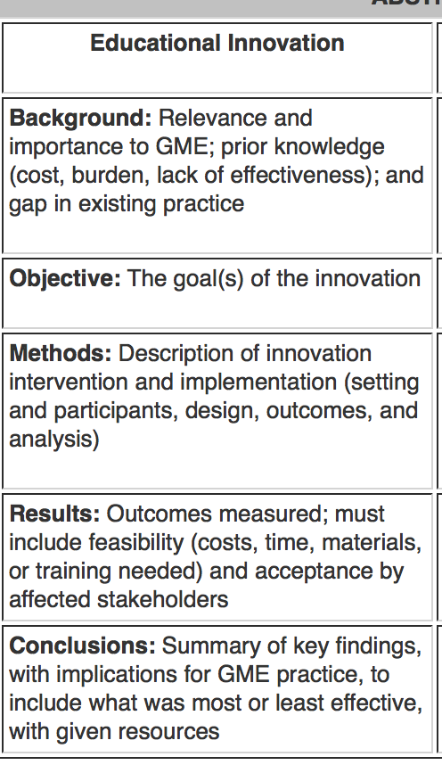

**Outline of Manuscript**

**Background**

* Briefly describe HITECH Act and meaningful use
* Discuss the medicolegal implications of copy and paste in the EMR and the subsequent internal policies many hospitals have adopted to try and police copy and paste behavior
* Introduce ECMC’s motivation to create its own copy and paste technology to assess internal problems with copy and paste
  + frustration over other services word-for-word plagiarizing of admission or consult HPIs
  + subsequent findings of numerous episodes of plagiarism
  + attempt to establish a threshold to determine which physicians would require disciplinary action led to surprising findings of copy and paste as effective work arounds to maximize clinical care

**Methods**

* Describe the process of how the plagiarism technology was created in collaboration with the IT team
* Describe weekly reports of offenders plagiarizing >95+%. How data can be sorted by provider name.
* IRB

**Results**

* Describe the capabilities of the plagiarism technology created
* Show how over the course of six months, we found which services/specialties were determined to be the repeat offenders
* Some improved, some didn’t, after demonstrating amount of plagiarism to services (maybe separate paper)
* Include histogram of plagiarism by percent and specialty
* Include figures demonstrating samples of plagiarized notes (for example, ortho was rounding on post op patient on a different service out of courtesy over the weekend when the patient was awaiting discharge to rehab, so nothing changed in the SOAP from one day to the next. Another example: an improving patient’s CK was still downtrending and the patient status was incrementally improving but otherwise stable, so the deliberately vague hospitalist progress note from one day to another was still applicable. ALC status.)
* When does copy and paste occur the most frequently? Beginning, middle, or end of admission. During transitions?

**Conclusion**

* Strengths: take inexpensive tool, automate into EHR, automatically generates reports, not labor intensive, identify egregious cases, educate, novel technology with the ability to be tailored to different specialties and individuals, study provided insight into the ways in which services created effective and safe workarounds to maximize time on patient care and education, prospective
* Limitations: only able to handle consecutive days, single site study

**Discussion**

Point 1: Justifiable legal and ethical concerns involved with copy and paste behavior

* list egregious copy and paste examples that have led to unsafe patient care, perpetuates false information, lead to note bloat
* list examples of when copy and paste created legal trouble for physician/hospital

Point 2: Situations in which copy-and-paste is an effective and not unsafe work-around

* identify studies that examine how mandatory EHR use has led to physicians dedicating significantly more time to documentation compared to actual patient care
* describe situations in which copy and paste may be effective workaround
* describe situations in which copy and paste may actually lend itself to safer, consistent patient care
* explain that better documentation does not necessarily translate to better patient care because in certain situations, providers simply know what is appropriate to document

Point 3: Potential explanations for why copy-and-paste behaviors exist

* physicians may not think they are plagiarizing if they are copying their own note or that of their colleague
* provide examples of how excessive use of copy and paste, especially in the training environment, may provide insight into underlying workflow issues
  + time limitations to have notes completed (e.g. surgical services or even medical services on an academic day full of conferences)
  + too many patients (i.e. not enough time within workday)
  + too many hand-offs (e.g. new or covering providers may be not want to cause distress if their interpretation of a physical exam finding is actually unchanged to a prior exam, and so copy-and-paste is used for consistency’s sake)
  + billing practices set certain specialty services up to fail (e.g. being able to bill for higher level consult note if more organ systems have been reviewed/examined)
  + this sort of behavior has always existed but the EMR has made it more visible

**Summarization and Recommendations**

* Copy-and-paste is an ongoing concern
* ECMC in collaboration with physicians and IT support created novel technology to identify plagiarism in clinical documentation
* In attempting to establish threshold at which punitive action might be necessary, the authors discovered that in certain situations copy and paste was an effective and not unsafe work-around
* Emphasize that physicians are being unfairly penalized with blanket copy-and-paste policies, and policies should be modified to address situations in which copy-and-paste is and is not acceptable. Otherwise, physicians are set up to fail.
* Legal support, or tort reform, should be provided to protect good physicians who use copy-and-paste strategically.
* The underlying issues that lead to copy-and-paste behavior must be addressed. Copy-and-paste is a symptom.